**A project report on**

**IOT based Smart Agri**

Course Title: Peripheral and Interfacing lab

Course Code: 316

Sec: B-1

Submitted to:

Abdullah Al Omar

Lecturer , Department Of CSE

Submitted By:

Fahmeda Akter (17101060)

Farzana Akhtar Lubna(17101064)

Shoumik Rouf (17101070)

**Introduction:**

We need food to stay alive. Main source of energy comes from pants and agriculture.

But as for the over growth of population the scarcity of food is also growing. And lands are being limited each day for cultivation.

There was this idea from a person to remove the primary element of agriculture which is soil from cultivation known as Hydroponic Agriculture.

**Components:**

#Arduino Uno R3

#Pvc pipes:

1.long(40cm)  x 2

2.mid(20cm)  x 4

3.short(6.5cm)  x 6

#Spray heads

1. 180’  x 12

2. 330’  x 4

#Connectors(pvc pipe):

1. 2 side  x 4

2. 3 side  x 7

#Water pump(5-10v)  x 1

#Moisture Sensor

#Relay Module

**1. Arduino Uno R3:**

The Arduino Uno R3 is a microcontroller board based on a removable, dual-inline-package (DIP) ATmega328 AVR microcontroller. It has 20 digital input/output pins (of which 6 can be used as PWM outputs and 6 can be used as analog inputs). Programs can be loaded on to it from the easy-to-use Arduino computer program. The Arduino has an extensive support community, which makes it a very easy way to get started working with embedded electronics. The R3 is the third, and latest, revision of the Arduino Uno.

A 16 MHz resonator, a USB connection, a power jack, an in-circuit system programming (ICSP) header, and a reset button. It contains everything needed to support the microcontroller; simply connect it to a computer with a USB cable or power it with a [AC-to-DC adapter](https://www.pololu.com/product/1463) or battery to get started.

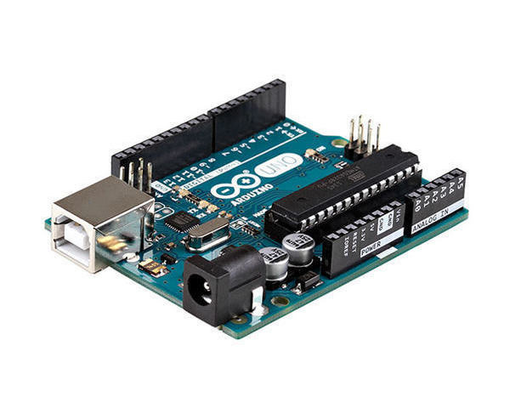 **Fig: Arduino Uno R3**

**2. Moisture Sensor:**

How Does the Arduino Soil Sensor Work? The soil moisture sensor consists of two probes that are used to measure the volumetric content of water. The two probes allow the current to pass through the soil, which gives the resistance value to measure the moisture value.

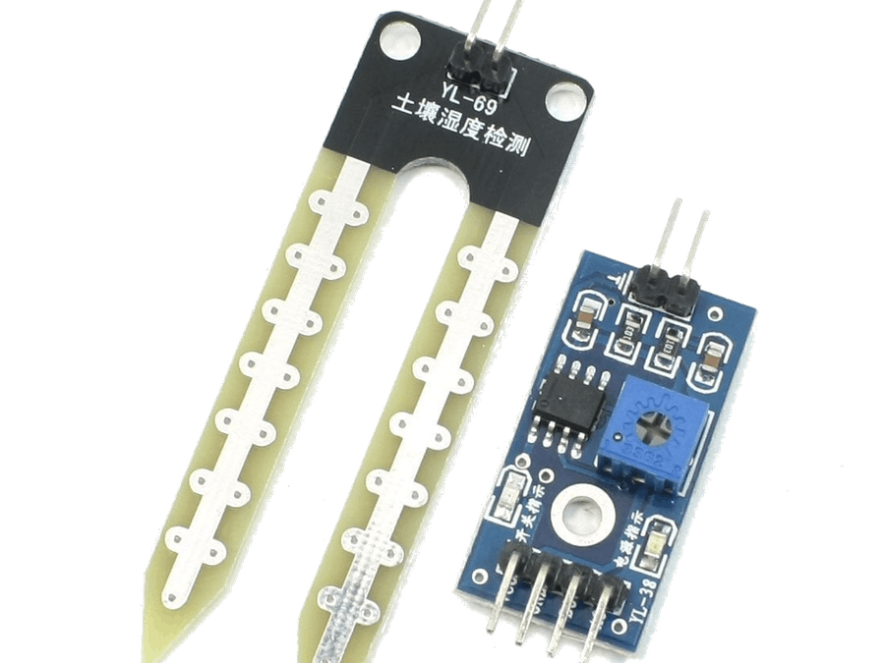

**Fig:Moisture Sensor**

**3. Pvc Pipe:** We use different pvc pipes to spread water mixed with minerals to the plants

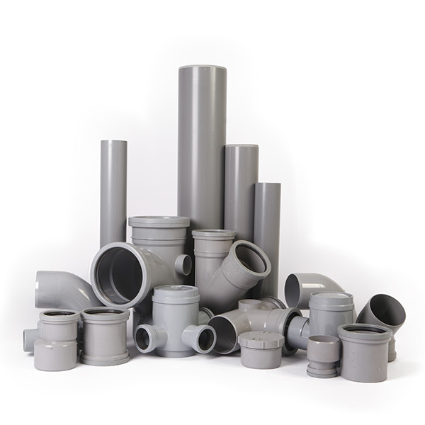**Fig: Pvc Pipe**

**4. Fig: Motor** 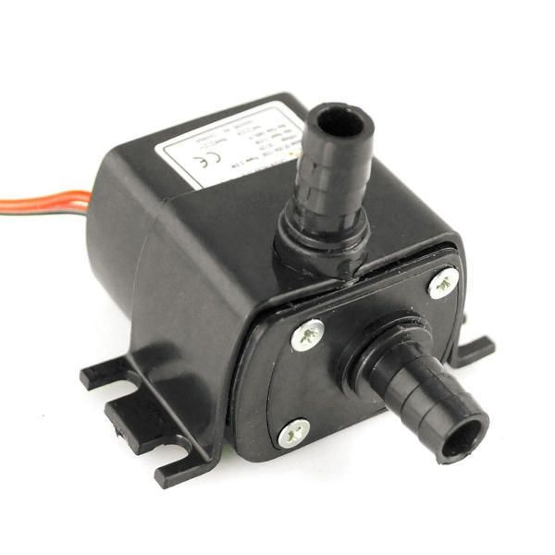

**5. Relay Module:**

A **relay** is basically a switch which is operated by an electromagnet. The electromagnet requires a small voltage to get activated which we will give from the Arduino and once it is activated, it will pull the contact to make the high voltage circuit.

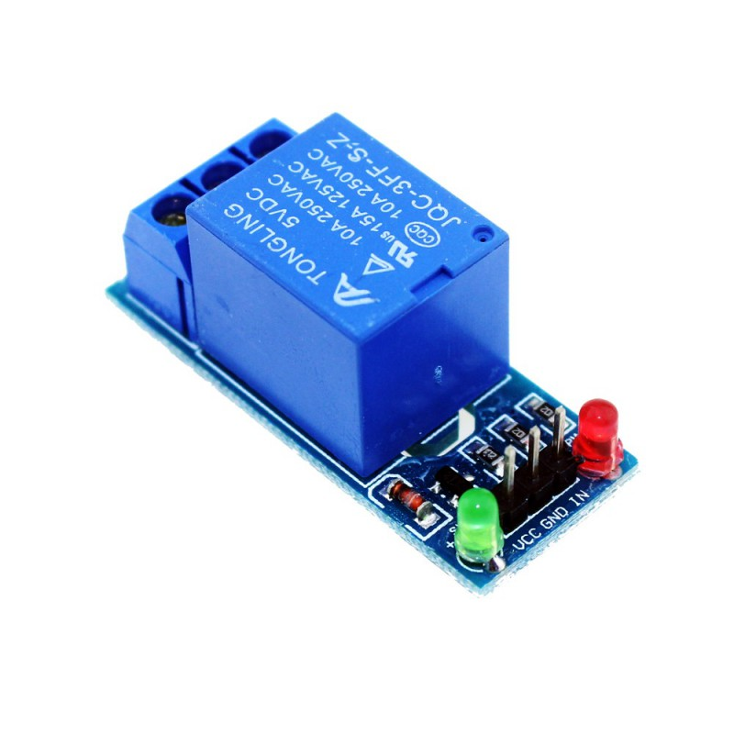**Fig:Relay module**

**6. Wifi Module:**

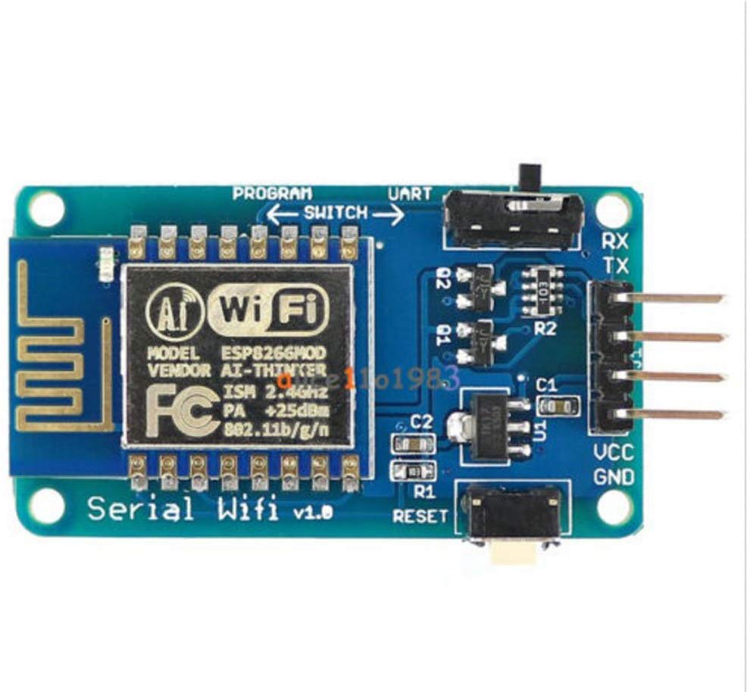**Fig: Wifi Module**

The Arduino Uno WiFi is an Arduino Uno with an integrated WiFi module. The board is based on ESP8266 WiFi Module integrated. The ESP8266 WiFi Module is a self contained SoC with integrated TCP/IP protocol stack that can give access to your WiFi network (or the device can act as an access point).

**Circuit Diagram:**

**Software Description:**

* Arduino software makes it easy to write code and upload it in the board.
* It runs on windows, mac and linux.

**Application:**

* Applied for where land or space is insufficient.
* Where we want to control ph of the soil to ensures the optimal nutrients uptake for plants.

**Working Producer:**

1. After setting up the probe of the Soil moisture sensor under the plant and making connection of digital output and 5v power from arduino board .

2. A motor is connected to the relay using a normally open configuration.The arduino controls the relay through pin .Pin is coonected to the relay IN pin.Finally soil moisture sensor is connected Relay IN pin.

3. We start with connecting the ESP8266 with the Arduino. ESP8266 runs on 3.3V and if you will give it 5V from the Arduino then it won’t work properly and it may get damage. Connect the VCC and the CH_PD to the 3.3V pin of Arduino. The RX pin of ESP8266 works on 3.3V and it will not communicate with the Arduino when we will connect it directly to the Arduino.

4. ESP8266 Wi-Fi module gives our projects access to Wi-Fi or internet**.** It is a very cheap device and makes your projects very powerful. It can communicate with any microcontroller and it is the most leading devices in the IOT platform.

5. Making all the necessary connections, upload the code Arduino and provide power supply to the Arduino ,motor.

**Prototype:**

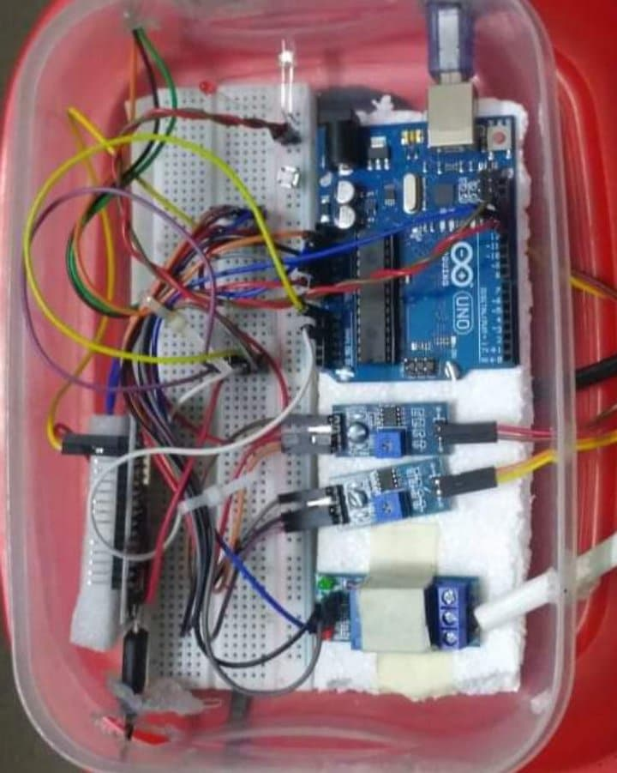

**Code Segment:**

int sensor_pin1 = A0;

int sensor_pin2 = A2;

int output_value1 ;

int output_value2 ;

void setup() {

Serial.begin(9600);

pinMode(13, OUTPUT);

pinMode(12, OUTPUT);

digitalWrite(13, LOW);

digitalWrite(12, HIGH);

Serial.println("Reading From the Sensor ...");

delay(2000);

}

void relay(){

if (output_value1<10 && output_value2<10) {

digitalWrite(13, LOW);

digitalWrite(12, HIGH);

}

else if (output_value1<10 || output_value2<10) {

digitalWrite(13, LOW);

digitalWrite(12, HIGH);

}

else {

digitalWrite(13, HIGH);

digitalWrite(12, LOW);

}

}

void loop() {

output_value1 = analogRead(sensor_pin1);

output_value1 = map(output_value1,550,0,0,100);

Serial.print("Mositure s1: ");

Serial.print(output_value1);

Serial.println("%");

delay(1000);

relay();

output_value2 = analogRead(sensor_pin2);

output_value2 = map(output_value2,550,0,0,100);

Serial.print("Mositure s2: ");

Serial.print(output_value2);

Serial.println("%");

delay(1000);

relay();

}

**Conclusion:**

We made a system named IoT Based Smart Agri using arduino uno,Relay Module , Moisture Sensor, Wifi Module.We are developing industries day by day and on the other hand losing land resources .The modern era is trying to reduce the man power and increase the uses of instrument.

So our project goal is to grow plant in limited spaces with automated water system.We hope to continue developing this project commercially.

**References:**

1.<https://www.youtube.com/watch?v=mcKSpwROvX8>

2.<https://www.fullbloomgreenhouse.com/hydroponic-systems-101/>

3.<https://home.howstuffworks.com/lawn-garden/professional-landscaping/hydroponics.htm>